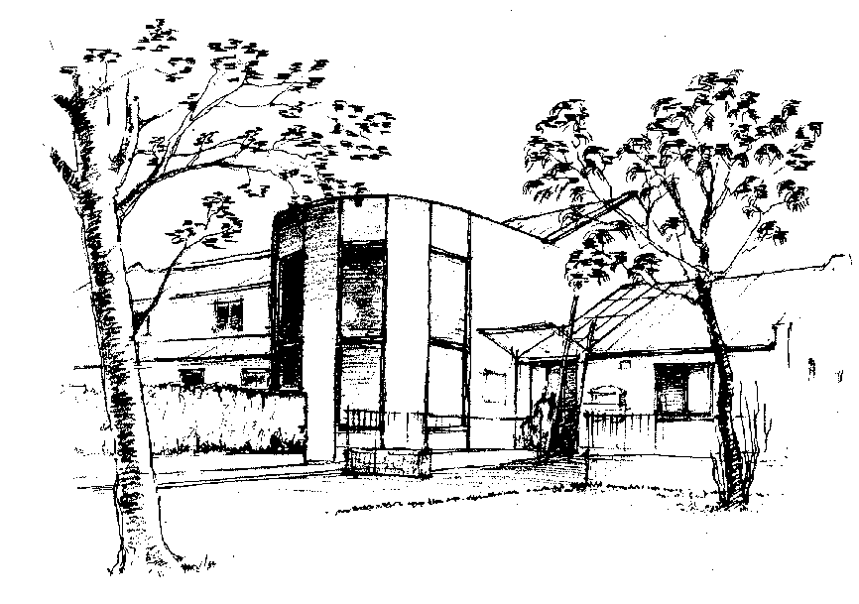
LADYWELL MEDICAL CENTRE EAST
PATIENT INFORMATION LEAFLET

Contact details:
Telephone: 0131 334 5000
Website: www.ladywelleast.co.uk
Our website provides further information about the Practice.

Surgery Opening Hours:
Monday-Friday: 8.00am – 6.00pm

Surgery Closures:
Saturdays, Sundays and Public Holidays: CLOSED
The Practice will be closed for training each day between 1.00pm – 2.00pm with emergency access only available.
The Practice will be closed for training afternoons throughout the year. Dates will be advertised in the practice and on the website.

THE PRACTICE
We are currently a Partnership of 7 Doctors. At present we also have Salaried GPs as well as training Doctors called Registrars.
The Partners
Dr Jane E Moore MBChB (1996) MRCGP DRCOG DFFP (Dundee)
Dr Alice Travers MBChB (1994) MRCGP DTMH DFFP (Manchester)
Dr Nairn McLeod MBChB (1998) MRCGP (Edinburgh)
Dr Kirsten Russell MBChB (Hons) (2000) MRCGP DRCOG Dip Obs (Birmingham)
Dr C Jane Miller MBChB (1993) MRCGP (Edinburgh)
Dr Susannah Scott MBChB (2007) MRCGP DRCOG DFSRH DGM (Edinburgh)
Dr Joanne Brown MBChB (2013) MRCGP FRMS (Edinburgh)
The Salaried GPs
Dr Alison Livingstone
Dr Scott Hogg
Salaried GPs are fully qualified GPs who are committed to the Practice without business involvement.

Registrars
The Registrar (also known as a GPST) is a qualified Doctor doing specialist training to become a GP. Overall, their training lasts 10 years and in this final phase they are gaining supervised experience in general practice. With your consent, the Registrar may record your consultation for teaching, training or assessment purposes.
Dr Alice King
Dr Awaiz Ahmed

Locums
At times of high workload, holiday or sickness Locum Doctors may be employed to assist the Practice. They are fully qualified general practitioners who wish more flexibility in their working hours.

Medical students
The Practice is committed to teaching medical students. The students may be present when the Doctor is consulting. You may be offered an appointment with the student, with a Doctor in attendance, or you may be asked to see the student before seeing the Doctor with whom you booked the appointment. Occasionally, consultations are recorded for teaching purposes. In all of these circumstances your consent will be sought beforehand and it is perfectly acceptable to decline. We are very grateful for patient support in this important venture of assisting the Registrar and students develop their skills.

SERVICES OFFERED
Emergencies out with surgery opening hours
Emergency out-of-hours cover via NHS 24 will provide medical assistance if you are unwell when we are closed. Please either call the Practice where a recorded message will give the number to dial for urgent medical attention or call NHS 24 directly on 111. NHS24 is available 24 hours per day, 7 days per week. NHS 24 is not a walk-in service and you need to telephone them if you require their services. You can access their website for advice on www.nhs24.com

Services we provide
•General medical care • immunisation of children (provided at the practice via an external NHS Nursing Team)• repeat and acute prescription ordering • medication monitoring and review • contraception advice • minor surgery • minor injuries • chronic disease monitoring • child health surveillance • care of patients addicted to drugs

Home visits
These are reserved for elderly, housebound or severely ill patients. If you are too ill to attend the Practice, please call0131 334 5000 before 11.00 am if possible, to arrange a home visit. Let the Receptionist know if it is urgent, and be prepared to give some details. Please do not ask for a home visit unless you are too ill to come to the surgery. If you or your child have a temperature or a rash, coming to the surgery will do no harm, but please inform the Receptionist when you arrive.

Repeat prescriptions
Repeat prescriptions are issued on your Doctor’s recommendation to allow a regular supply of long term medication. Your Doctor will ensure that your treatment is reviewed regularly. Medication reviews are important for your wellbeing – please make a routine appointment if a review is requested.
A prescription will be available 2 full working days after your request is received by us. You can request prescriptions via our website www.ladywelleast.co.uk(there is a simple registration process to complete online first); or by handing in your request at Reception or via your Pharmacy. If you order via your Pharmacy you should allow a little bit of extra time as the 2 full working days starts when we receive the request.

Results
Results for most tests can be given over the phone. If you are phoning for test results please phone after10.30am. Please note that it is the responsibility of the clinician who initiated the test to provide the result, so if your test was taken at the hospital and not initiated by your GP, the hospital should provide the result as the GP may not be able to interpret the result fully. We would ask you to allow a week before you call for your result unless your clinician has advised of a different timescale – shorter or longer.

Messages for specific Doctors
Should you wish to speak to or leave a message for a particular GP, the message will be forwarded to that GP and they will do their best to respond within 1 week.

New patient registrations
People wishing to register with the Practice should obtain New Patient Registration Forms from the Practice or download the Registration Form from the website. In order for new patients to register, the Practice requires a completed registration form and medical questionnaire as well as two forms of ID for each person –one proving right to NHS healthcare and one proving that you live in the practice boundary area. One photographic, for example: passport, driving licence or ID card and the other with proof of address, for example: a bill or tenancy agreement. Each patient registering should bring in their own forms and ID, except in the case of children (under 16s) where the parent/guardian can bring them in and housebound patients where a family member/carer can bring them in. We accept completed new patient application forms from 9.00am - 5.30pm, Monday to Friday. Out with these times you will be given forms to take away and complete. We register new patients every 2nd week in rotation with Ladywell Medical Centre West.

GUIDE TO THE APPOINTMENTS SYSTEM

We encourage continuity of care by asking you to see the same Doctor whenever possible (this cannot be guaranteed).
PLEASE CANCEL ANY APPOINTMENTS WHICH YOU DO NOT REQUIRE AS THESE CAN BE USED FOR OTHER PATIENTS.
• GP routine appointments: These can be booked up to 2 weeks in advance.
• GP same day appointments: These are released at 8.00am each day and are limited in number. They are available on a first come, first served basis.
• GP urgent appointments: These are allocated by the Duty Doctor. These should only be used to discuss one relevant urgent medical problem.
• GP extended hours appointments: We offer a mixture of early morning and evening appointments. These are released the week before and are dependent upon GP availability. These appointments are aimed at those who have difficulty attending the surgery during daytime working hours. There are no Nursing or walk-in services at this time.
• Appointment length: Routine appointments are 15 minutes long. If you have a number of problems, it may not be possible to deal with them all in one appointment and the GP may ask you to make a further appointment.
• Nurse appointments: These can be booked up to 6 weeks in advance.

Urgent appointments (by phone)
- If you have an urgent problem that you feel cannot wait until the next routine appointments and needs medication, attention or advice on the same day, and all the routine appointments have been used, the Reception staff will take your contact details and details of the problem and add it to the list of contacts for the Emergency Doctor.
- The information you provide enables the Emergency Doctor to assess if an emergency appointment for that day is required or if your problem could be effectively and safely treated over the telephone. It may be possible, for example, for you to treat the symptoms at home with guidance from the GP, to be put in touch with one of our Nurses, to go to a Pharmacy for prescription medication or to be referred directly to a hospital department for tests.

THE PRACTICE TEAM
Practice Management
The Practice Manager, Wendy Gaffney, manages all of the business aspects of the practice such as making sure that the right systems are in place to provide a high quality of patient care, human resources, finance, patient safety, premises, equipment and information technology. The Practice Manager supports the GPs and other medical professionals with delivering patient services and also helps to develop extended services to enhance patient care. She will be pleased to hear any comments you may have regarding your service.

The Assistant Practice Manager supports the Practice Manager and Practice as a whole, deputising in the Practice Manager's absence and ensures a high standard of service is provided to patients at all times. The Assistant Practice Manager is Line Manager for the reception and administrative teams and ensures these teams carry out their duties in a timely and efficient manner, within the Practice Guidelines.

The Reception and Administrative Team
Our Administrative staff are a highly trained and dedicated team who will deal with your needs. They make appointments, take messages, respond to requests for visits and deal with prescription requests. They log information on our computer and inform patients of test results once the Doctor has seen and approved them. Our reception and administrative staff have been asked by the GPs to employ patient care navigation when booking appointments. As a result, they will always ask for brief details of your condition in order for the GPs to assess the degree of urgency. Such information is dealt with in complete confidence.

The Nursing Team
The Practice Nurses are available from 8.30am – 5.30pm Monday to Friday. They are qualified Nurses who see patients for general nursing procedures - dressings, cervical smears, stitch removal, first aid, general health promotion (including dietary advice and smoking cessation), hormone therapy checks and contraception (including emergency contraception).
They also undertake long term conditions monitoring on areas such as:
• Heart disease prevention/stroke
• Diabetes
• Asthma/respiratory

The Nursing Assistant carries out duties under the supervision of the Nursing staff. For example: taking blood samples, blood pressure monitoring, assisting GPs with minor surgery. She is available Monday to Friday at various times.

The Phlebotomists are responsible for taking blood samples. Appointments are available from 8.10am, Monday to Friday. The Domiciliary Phlebotomist visits patients in their own homes if they are housebound.

Please book nursing appointments via telephone or at Reception.

District (Community) Nurses
The District Nursing team provides care and support for patients in their own homes. They can be contacted directly on 0131 316 4053 from 8.00am to 4.30pm Monday to Friday. An answering machine is available if the District Nurses are out on calls and is checked at regular intervals. The District Nurses work closely with GPs, carers, hospitals, hospice services, social work, physiotherapy, occupational therapy and chiropody services. After 4.30pm and at weekends please contact NHS 24 on 111.

Health Visitors
The Health Visitors are qualified nurses who, with additional training, have specialised in community health care. They support families, primarily with pre-school children, advising on many family health issues including feeding and sleep problems, as well as behaviour management. Health promotion advice and information for other age groups is also available. They work closely with many other agencies including nursery schools and can offer assessment and make referrals when necessary. They can be contacted on 0131 334 5086 from 8.30am - 5.00pm Monday to Friday. An answer machine will take messages if they are out of the office.

Midwives
Midwives are based at Pennywell All Care Centre, 1d Pennywell Gardens, Edinburgh, EH4 4UA.
Contact telephone number: 0131 286 5023. Appointments can be made and changed by phoning the Midwives office. They share with GPs in providing care for expectant mothers. In an emergency, the maternity services can be contacted 24 hours on 0131 242 2657 for the Royal Infirmary of Edinburgh or 01506 524 125 for St John’s Hospital in Livingston.
Pregnant women can self-refer for a first Midwife appointment and scan appointment on 0131 536 2009, Monday to Friday 9.00am – 4.45pm.

Welfare Rights Officer

Should you require any welfare rights advice, please call the Granton Information Centre office on 0131 551 2459 or 0131 552 0458. If you are a new client you will be sent a mandate in the post which you will need to complete, sign and return to them directly before they will be able to do the phone appointment with you. They will give you all the information you require.

OTHER IMPORTANT INFORMATION
Disabled access
There is access by ramp to both East and West entrances of Ladywell, with a disabled toilet in each wing.

Data Protection Legislation and Access to medical records
We keep computerised and paper medical records. You have the right to access your own records by giving us the detail of your request, either in writing or verbally. We have one calendar month to respond to your request. Further details of Subject Access Requests can be found on our website or from Reception. Doctors responsible for the management of the health services in the locality may be given limited access to these records. It is a national requirement that patients with diabetes have information about their care recorded on a central register. Please find further detail of our privacy statement and how we use you health records on our website or from Reception. This ensures appropriate care can be offered and services can be planned. Only anonymised data is available outwith the Practice.

Patients’ rights and responsibilities
RIGHTS
• Patients have a right to confidentiality.
• Where possible, patients may choose to consult any Doctor with the Practice, subject to availability of appointments or home visit workload. In cases of short notice or emergency, the Practice nominates an Emergency Doctor in rotation.
• A chaperone may be requested by any patient if they would prefer to have one.
• The practice operates an anti-discrimination policy.
• The practice strives to run appointments on time. If a surgery is running more than 30 minutes late, patients will be notified.

RESPONSIBILITIES
• To participate in own healthcare and treatment.
• To attend booked appointments or cancel, giving 24 hours notice if possible.
• Abusive or threatening behaviour will not be tolerated and will result in removal from the list.
• Patients treated for drug addiction are required to sign a Contract Agreement.

Suggestions and complaints
We welcome suggestions and comments which will help us improve our service. We operate a complaints procedure which meets national guidelines. Reception staff will be happy to give you further information. We always aim to treat our patients as individuals and you have a right to expect due respect and politeness at all times. Our staff also have a right to personal safety and to be treated courteously. Any patients who exhibit abusive or violent behaviour will be removed from the Practice list.

Private Services and Payments to the Practice
Please remember that some certificates, reports and medical examinations are not covered by National Health Service arrangements. There is a list of fees at Reception. Driving medicals and insurance medicals require special, pre-arranged appointments. Legal and other reports (such as Power of Attorney or Travel Claim forms) may require some time to prepare as these are completed by the Doctors outside the normal working day. Some fees are payable in advance of work being undertaken. Reception staff will advise you of fees and which items this affects. All of our NHS work is funded through our contact with NHS Lothian and governed by the PCCO (Primary Care Contractor Organisation). Their address is PCCO, 2nd Floor, Waverley Gate, 2-4 Waterloo Place, Edinburgh, EH1 3EG, if you wish to contact them about any aspect of primary medical care in this area.

Change of Details
Please notify the Practice of any change of name, address or telephone number so that we can update your records. As above, if your new address is outwith our boundary area we would ask you to register at a Practice nearer your new home. If you wish to change your name as a result of marriage, for example, or change your child’s name, we require to see legal proof of this change.

How we use your data
The practice is an independent contractor providing primary medical services by way of a contract with NHS Lothian, made under the National Health Service (Scotland) Act 1978 (the 1978 Act). It is one of the organisations which form part of NHS Scotland (NHSS).

NHS Lothian is a public organisation created in Scotland under section 2 of the National Health Service (Scotland) Act 1978 (the 1978 Act). It is one of the organisations that form part of NHS Scotland (NHSS).
Ladywell Medical Centre East will be Joint Data Controllers with NHS Lothian in respect to the data held about you in the practice.
You can view the NHS Lothian Data Protection Notice here www.nhslothian.scot.nhs.uk/yourrights/dataprotection
The personal information we use includes information that identifies you such as your name, address, date of birth, postcode, next of kin details and any other personal information that you provide when you register with the practice.
We will also use your current and past medical history which includes detail about your treatment and care, notes and reports about your health, medication, results of investigations such as laboratory tests and x-rays.

Practice Area: Our Practice boundary can be found on our website at www.ladywelleast.co.uk or can be viewed at a map in Reception. Patients can only be accepted by our Practice if they live within the area shown by the dotted lines on the map. If you move outside the area, we would ask you to inform the Practice and register with a Doctor in your new locality.

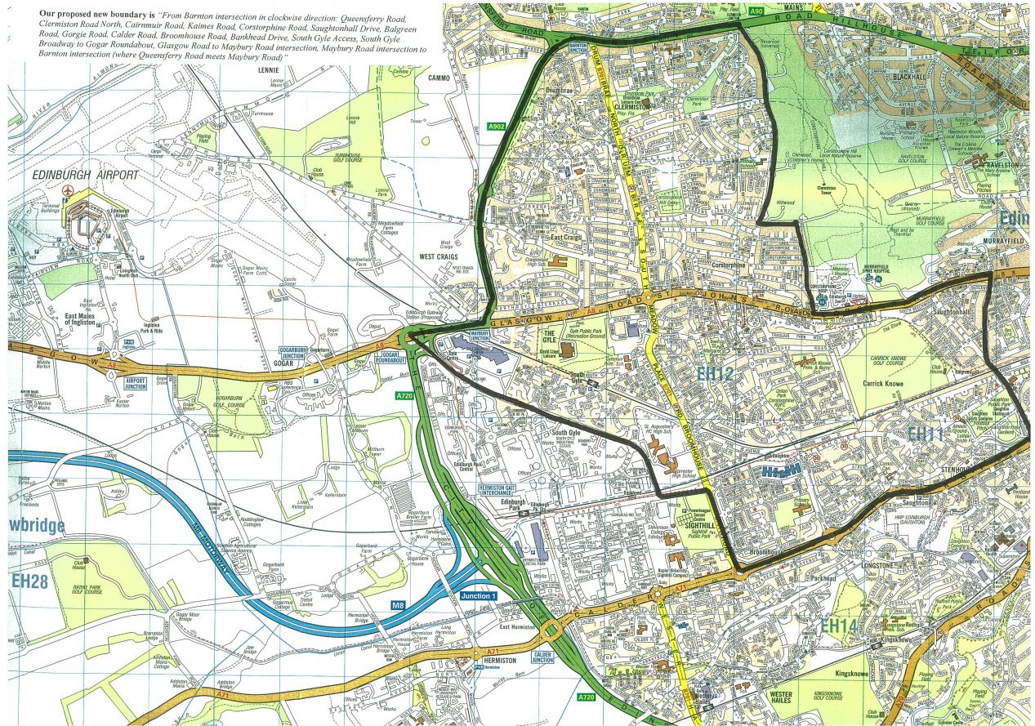

Self-treatment for common illness and accidents
MINOR AILMENTS SERVICE: All Pharmacists can recognise many common health complaints. They can give advice or, where appropriate, medicines that will help to clear up the problem. If your problem is more serious and needs the attention of a GP, your Pharmacist will recognise this and advise you to see your GP.

A NOTE ABOUT ANTIBIOTICS: Antibiotics only work on bacteria, and have no effect on viruses like coughs, cold and flu. The best treatment is with the simple remedies outlined below. We only use antibiotics when we suspect there is secondary bacterial infection. Overuse of antibiotics can cause complications like thrush, diarrhoea and rashes.

COLDS AND SORE THROATS: Take plenty of fluids, and Paracetamol (as recommended for your particular age group). Steam inhalation scan also help congestion.

COUGHS: These can be soothed by hot drinks. If the cough is particularly irritating, steam inhalations can be worthwhile. If you are bringing up coloured phlegm, you may need your chest checked.

TEMPERATURES: Children often run temperatures without other symptoms. They need to be cooled down and then they will feel much better. Do remove their clothes down to vests and pants and keep the room temperature down. Use Calpol or Disprol etc., and, if necessary, sponge them down with lukewarm (not cold) water. If there is no improvement within 24 hours, then they should see a Doctor.

DIARRHOEA: Diarrhoea is usually caused by a virus and is therefore unable to be treated directly. In most cases taking small and frequent amounts of clear fluids for 24 hours or so will allow the tummy to settle. If symptoms are persistent or the patient is becoming generally less well rather than improving, consult your Doctor.

NOSE BLEEDS: Blow your nose to expel contents then sit leaning forward and press firmly to close the fleshy part of the nose, breathing slowly through an open mouth. Continued pressure for ten minutes allows most nosebleeds to stop.

BURNS AND SCALDS: Immediately cool with copious amounts of cold water. Continue for 10-15 minutes until the pain subsides, then cover loosely with dressing. If the burn is large or the skin is broken, consult your Doctor or attend Accident and Emergency.

SPRAINS: Use a cold compress or ice pack to reduce swelling. Elevate and rest the injured area. Take Paracetamol or Aspirin for pain relief.

STRAINS: If unable to weight bear with leg or ankle injuries, you should consult the Doctor.

FITS: Place patient in recovery position (on his or her side) and ensure the airway is clear. Do not attempt to restrain and do not put anything in the mouth. If the patient is a feverish child, remove clothing and cool with tepid water. Contact your Doctor.

DENTAL PROBLEMS: For toothache and other dental problems, please contact your Dentist.

CHILDHOOD ILLNESSES: Chickenpox is very common and produces crops of spots, which rapidly blister. Calamine will help to cool the skin and ease the itch. Paracetamol liquid may be required for fever. Due to immunisations, other formerly common illnesses such as measles and mumps are less often seen now. Many viral infections can produce a rash, and the child may be miserable and feverish for a few days. In most instances, symptoms are mild and the child will require only rest, ample fluids and Paracetamol for fever. If a child is very unwell, or you have difficulty with either fluid intake or temperature control, we are pleased to offer advice and arrange to see your child if necessary.

MENINGOCOCCAL RASH: Meningitis is a very rare condition but sometimes with meningococcal meningitis a rash may develop very rapidly, which is typically like tiny bruising spots which join under the skin. If such a rash develops, a glass or something clear should be pressed against the skin to see if the rash disappears. If the rash persists contact your Doctor as an emergency.

